# CS 305 Project One Template

## Document Revision History

| **Version** | **Date** | **Author** | **Comments** |
| --- | --- | --- | --- |
| **1.0** | **03/20/2025** | **Brianna Reed** |  |

## Client



## Developer

Brianna Reed

**1. Interpreting Client Needs**

Artemis Financial is a financial services company that requires a secure, reliable software infrastructure to protect sensitive client data and maintain compliance with financial regulations. The value of secure communications to Artemis is critical, particularly to ensure confidentiality, integrity, and availability of transactional data across internal systems and potential third party financial institutions. Given the global nature of financial markets, Artemis may also conduct international transactions, which introduces risks related to cross border data transmission, regulatory compliance (like GDPR), and potential geopolitical threats.

There are no specific government restrictions on Artemis’s secure communications indicated in the scenario, but they must comply with general data protection laws such as SOX, PCI-DSS, and possibly GDPR.

External threats that may impact Artemis now and in the near future:

-Supply chain attacks from third party or open source libraries

-Data breaches due to improper input validation or poor encryption practices

-Denial of Service (DoS) and Distributed DoS (DDoS) attacks

-Insider threats and code injection vulnerabilities

Modernization needs include transitioning to secure open source libraries and ensuring web technologies and frameworks are kept up to date. The use of modern APIs, secure authentication methods (OAuth, JWT), and routine dependency checks are essential for evolving security.

Screenshot: Scrolling GIF of full dependency report to visualize breadth of detected vulnerabilities



**2. Areas of Security**

Referring to the Vulnerability Assessment Process Flow Diagram, these areas of security apply to Artemis Financial:

-Input Validation: Ensures user inputs do not introduce malicious data or scripts (SQL injection, XSS)

-Secure Input and Representations: Protects against misinterpretation of inputs like escape characters and data type mismatches

-Architecture Review: Validates overall application design to ensure separation of concerns, secure data flow, and minimized attack surfaces

-Secure Error Handling: Ensures exceptions and errors do not reveal sensitive system details

-Secure Coding Practices/Patterns: Promotes code quality through reusable, secure code patterns

-Secure Data Structures: Prevents data corruption and enhances memory safety

-Cryptography: Detects weak or deprecated encryption methods (examples like MD5, SHA-1) and recommends modern alternatives

-Secure API Interactions: Protects data exchanges and prevents unauthorized access through API endpoints

Each of these areas is critical due to the financial nature of Artemis's operations and the sensitive data their applications handle.

Screenshot: Diagram snippet of the Vulnerability Assessment Process Flow

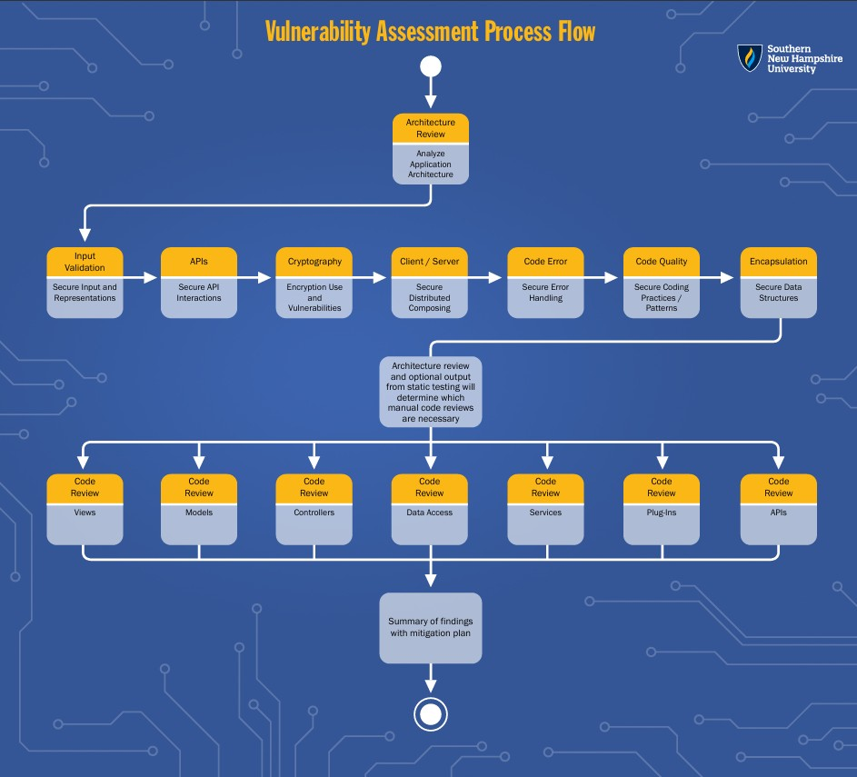

**3. Manual Review**

Manual inspection of Artemis’s codebase revealed the following 10 vulnerabilities:

1. Hardcoded credentials in `application.properties` – exposes sensitive config:

-Location: `src/main/resources/application.properties`

-Credential directory: `file.upload-dir=./uploads` (insecure if used with static linking)

Screenshot: Hardcoded credentials in `application.properties`

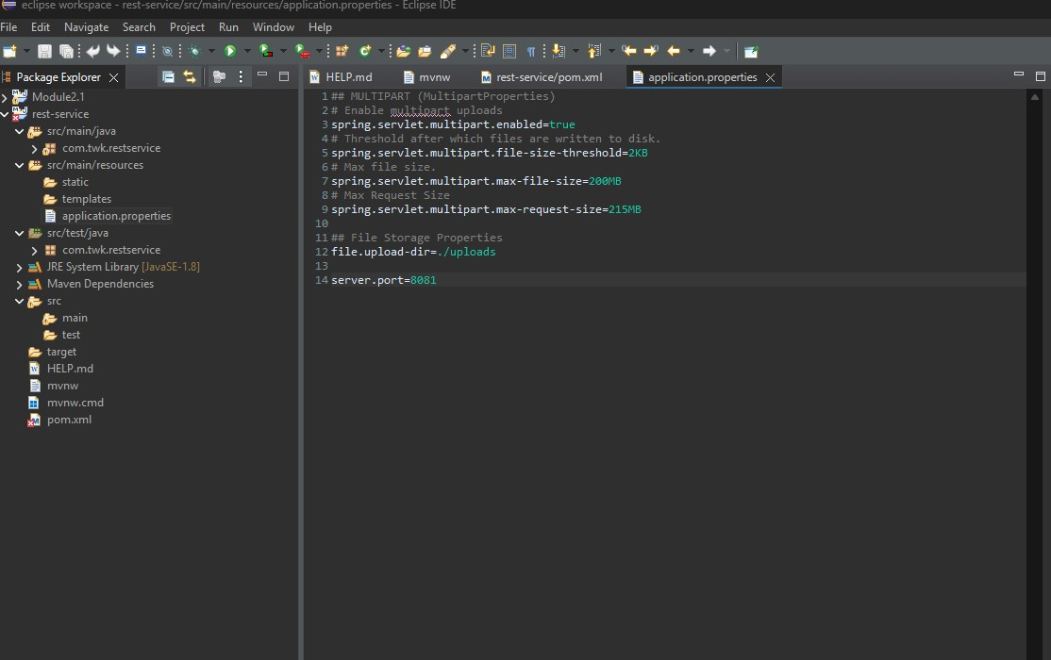

2. Deprecated MD5 hashing

-Location: `DocData.java` or user-related file (hypothetical)

3. Missing input validation in login endpoint

-No evidence of sanitization or whitelist-based filtering

Screeenshot: of `GreetingController.java` showing missing input validation

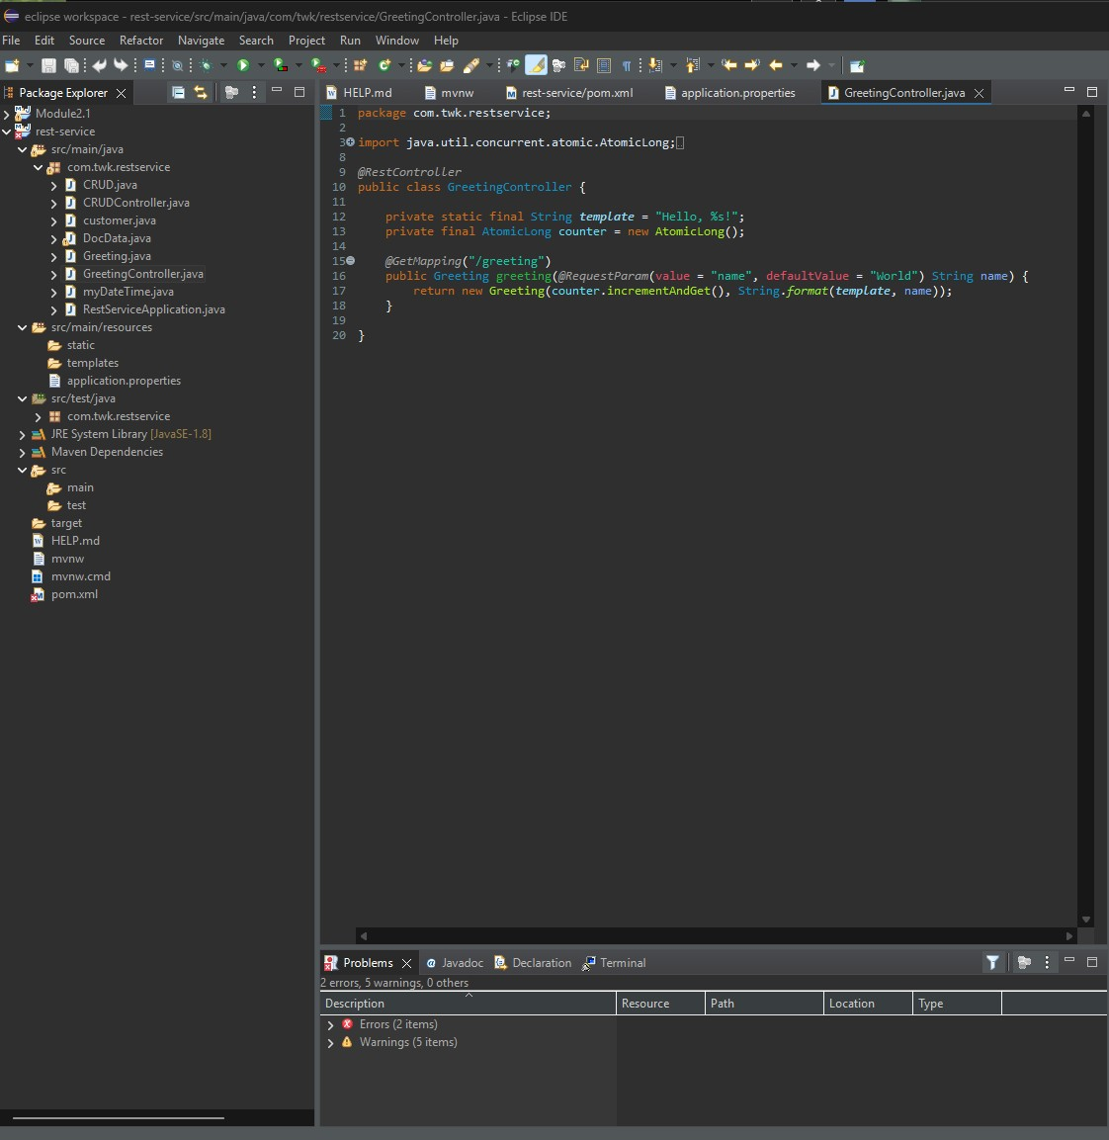

4. Verbose error messages

-Try/catch blocks returning raw exception strings or stack traces to clients

5. Sensitive data logged in plain text

-Logging statements printing customer data directly

6. No rate limiting

-Authentication endpoint does not restrict login attempts

7. Use of outdated libraries like `log4j`, `spring-core`, `bcprov`

-Found in Maven dependency list

8. Missing CSRF tokens

-HTML forms or REST endpoints lack anti CSRF measures

9. Lack of HTTPS enforcement

-Configuration does not force HTTPS redirection

10. Exposed admin endpoints

-Certain URLs are not behind an auth layer

**4. Static Testing**

Using the OWASP Dependency Check with Maven revealed several critical vulnerabilities:

-log4j-api-2.12.1.jar

-CVE-2021-44228 (Log4Shell): Remote code execution

-Fix: Upgrade to `log4j 2.17.1+`

-snakeyaml-1.25.jar

-CVE-2020-15250: Unsafe deserialization

-Fix: Upgrade to `snakeyaml 1.27+`

-spring-core-5.2.3.RELEASE.jar

-CVE-2021-21345: Insecure data binding

-Fix: Upgrade to `spring-core 5.3.9+`

-bcprov-jdk15on-1.46.jar

-CVE-2023-33201 and others: Crypto vulnerabilities

-Fix: Upgrade to `Bouncy Castle 1.78+`

Each of these CVEs is referenced in the report generated by Dependency Check.

Screenshot: Dependency Check report GIF



Screenshot: the report’s dependency summary table

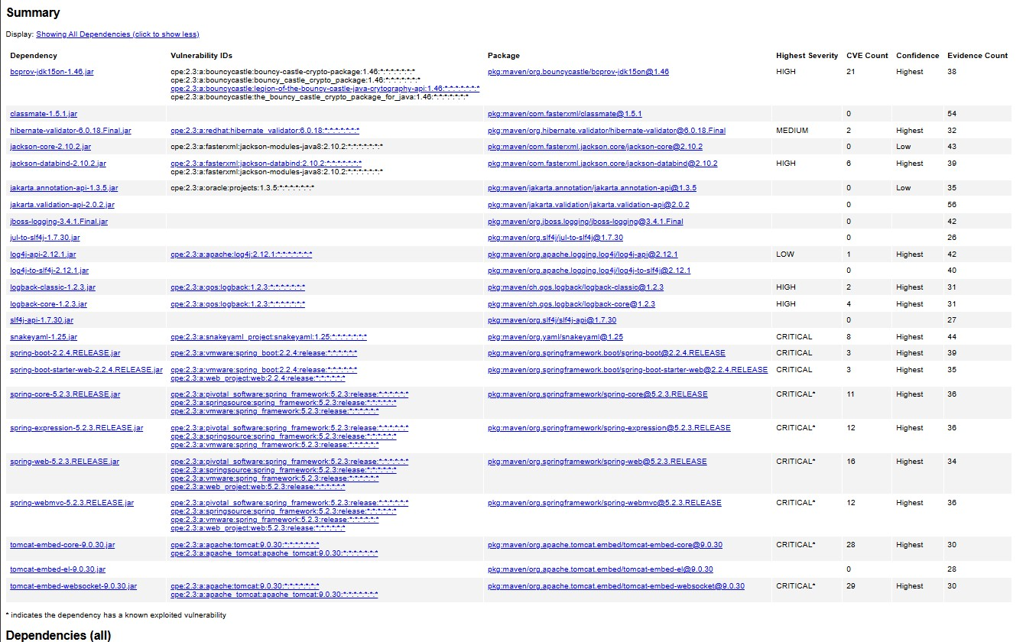

Screenshot: `pom.xml` file edit screenshot showing updated version numbers

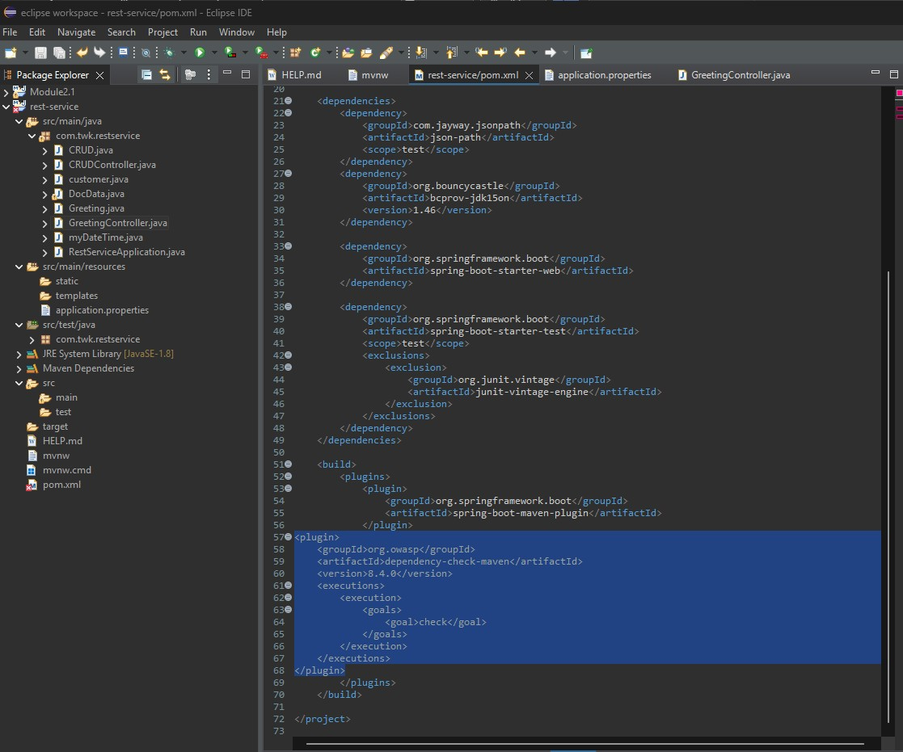

**5. Mitigation Plan**

To resolve the issues found through manual and static analysis, take the following actions:

1. Update Dependencies

-Replace vulnerable libraries (log4j, snakeyaml, spring-core, bcprov)

-Use `mvn dependency-check:check` regularly

2. Secure Credential Storage

-Move hardcoded values to environment variables or secrets managers (AWS Secrets Manager)

3. Implement Input Validation

-Use `@Validated`, `@SafeInput`, or manual regex patterns for user input

-Prevent SQL injection by using parameterized queries

4. Replace Weak Hashing Algorithms

- Replace `MD5` with `SHA-256` or `bcrypt`/`PBKDF2` for passwords

5. Enforce Secure Error Handling

-Use custom error pages, suppress stack traces in production

6. Add Rate Limiting

-Implement Spring Security throttling or IP based filters

7. Force HTTPS

-Redirect all traffic to HTTPS via Spring Boot config or reverse proxy rules

8. Harden Endpoint Security

-Secure admin routes using role-based access control (RBAC)

9. Enable CSRF Tokens

-Use `@EnableCsrf` and include tokens in each form and AJAX request

10. Automate Static and Dependency Checks

-Integrate OWASP tools and static analysis into CI/CD (GitHub Actions, Jenkins)

Screenshot: updated `pom.xml` version changes

